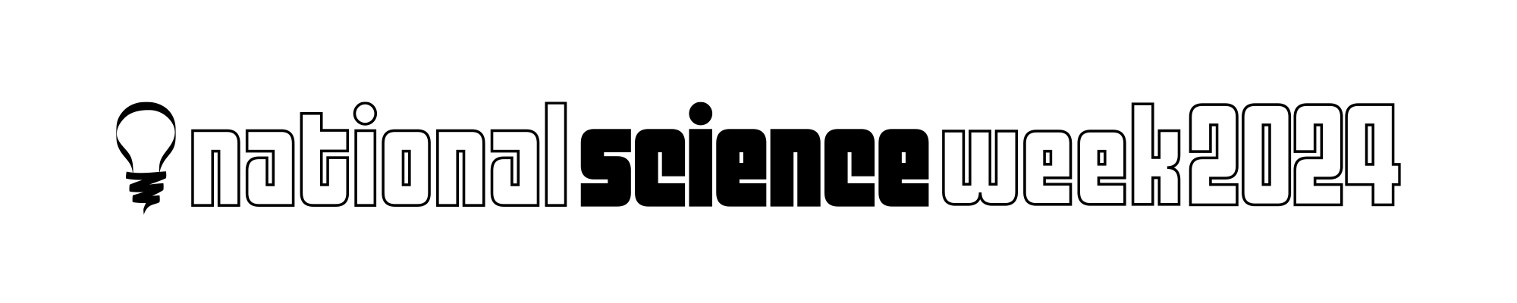

South Australian Community

Grants Guidelines

National Science Week is a program of Inspiring Australia, a national strategy for getting Australians engaged with science, technology, engineering, maths and medicine (STEMM) and is an initiative of the Australian Government.

National Science Week 10-18 August www.scienceweek.net.au

National Science Week is Australia’s annual celebration of STEMM. Running each year in August, it features more than 1000 events around Australia, including those delivered by universities, schools, research institutions, libraries, museums, and science centres.

Grants available
$2500 for events and activities in metropolitan Adelaide
$3000 for events and activities in regional and remote areas

Purpose of the grant
- Inspire wide community participation in STEMM, in line with the Government’s commitment to diversity in STEMM.
- Provide an opportunity to acknowledge and celebrate the contributions of Australian scientists to the world of knowledge.
- Encourage an interest in science pursuits among the general public.
- Encourage younger people to become fascinated by the world we live in.
- Encourage new and innovative ways of engaging with audiences.

Who can apply for a grant?
- The Grants are open to any sole trader, community group, organisation, business, industry body or university.
- Event or activity producers/hosts must have their own public liability insurance cover.
- Schools are unable to apply for the Grants, however there are grants available through ASTA.

Target audiences for the grant
Grants will be given to projects targeting groups currently underrepresented in STEMM, including, but not limited to:
- First Nations people
- Culturally and Linguistically Diverse (CALD) people
- Women and girls
- People with disability
- People from low socio-economic backgrounds
- Neurodivergent people
- LGBTQIA+ people
- People who face age-based discrimination
- Regional and remote communities

Types of events and activities eligible for a grant
You are encouraged to consider innovative ways of bringing STEMM to new audiences. The types of events and activities may include but are not limited to:
- hands-on science workshops or field activities
- science fairs, expos, shows or exhibitions
- science through the arts activities
- interactive online events
- podcasts
- video productions
- virtual tours
- webinars
- citizen science activities
- digital storytelling
- content creation
- live streaming of presentations and lectures
- performances

Funds may be used for direct project delivery. For example:
- resources and materials related to the event
- venue hire
- hire of equipment such as AV equipment
- presenter / speaker / creator fees and their travel
- paid advertising, up to 10% of the grant amount, this may include printing flyers or paid social media advertising

Ineligible activities for a grant
The funding may not be used for the following:
- activities for only school students (either in class or off site)
- research projects
- conferences – delivery or attendance
- curriculum development
- permanent infrastructure
- surveys
- teacher training
- catering or supply of refreshments for audiences at the funded event
- payment of wages or salaries of your organisation’s staff
- software development

Grant Assessment Criteria
All grants will be assessed against the following criteria.

- The event must be in August 2024
- Does the event or activity do any of the following?
- Harness curiosity or broaden scientific literacy.
- Encourage an interest and participation in STEMM related pursuits (hobbies, study, and careers).
- Engage underrepresented group(s) in STEMM (see list above).
- Does the application?
- Have a clear description of the event or activity.
- Is the requested grant amount appropriate for the number of participants/audience size?
- Are the objective(s)/outcome(s) of the event or activity clear?
- Is there are clear promotion and marketing plan?
- Is the budget clear and does the projected expenditure appear accurate?

An evaluation report template will be provided and must be submitted within 8 weeks of the completion of the event or activity.

Grant Assessment Process
All applications will be assessed by members of the SA National Science Week Coordinating Committee. Usually, more applications than can be funded are received.
To enable the committee to support more projects, some applications may receive partial funding.
All decisions are final, and not negotiable.

By accepting a grant, you agree to the following:
- To include the following Audience Survey questions in the registration for your event or activity and provide a summary of the answers to these questions as part of your Post Event Report.
  - your postcode
  - your age
  - gender (male, female, non-binary, other)
  - are you attending with children (under 18 years)?
  - do you currently work/study in a science, technology, engineering, maths or medicine related field?
  - how did you hear about the event/activity? (social media, email newsletter, word of mouth, print, radio, other)
- Register your event on the National Science Week website www.scienceweek.net.au.
- Submit an invoice for your grant no later than 30 June 2024.
- Provide a promotional image, links to registration (if used), text for use on social media and in the Inspiring SA newsletter not later than Monday 17 June 2024.
- Use National Science Week and Inspiring Australia logos on all marketing and event promotion materials https://www.scienceweek.net.au/resources/logos-graphics/
- Submit a Post Event Report by 10am Tuesday 1 October 2024.
- If photos or video are shared online use #scienceweek.
- Seek feedback from audience/participants (suggestions on how to do this will be provided).

As a grant recipient you will be able to:
- Order free National Science Week merchandise including tote bag and t-shirts for your event staff and volunteers.
- Participate in free online media training.
- Be invited to an exclusive ‘We Survived National Science Week’ event to meet other grant recipients and the SA National Science Week Coordinating Committee.
- Receive a summary report of the Audience Survey questions to help you better understand the National Science Week audiences.

If you have any questions about the grants and the application process, contact:
Alison Kershaw
Inspiring SA Program Manager
inspiringsa@sa.gov.au
8273 9107 during office hours

Send completed applications to inspiringsa@sa.gov.au

by 5pm Wednesday 15 May 2024

