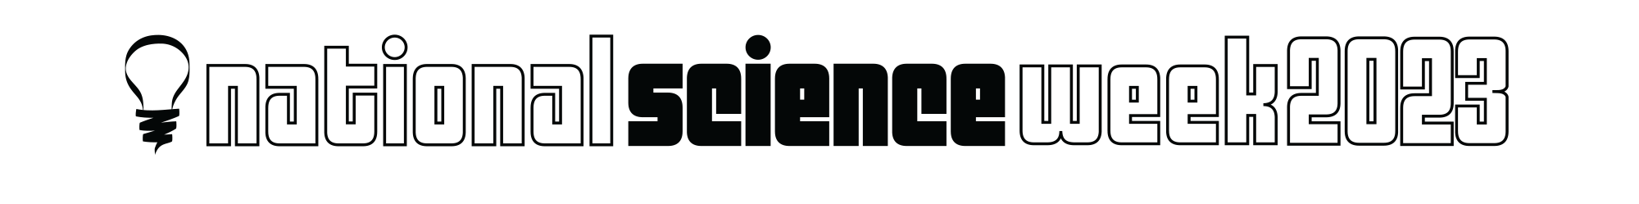

UNSUNG HERO AWARDS OF SOUTH AUSTRALIAN SCIENCE AND SCIENCE COMMUNICATION

The awards celebrate those whose work is yet to be celebrated. The awards may assist the recipients promote their work, publicise important issues and focus attention on their field of work and give their work public credibility.

There are 2 awards offered:

- Unsung Hero of South Australian Science - for science and research endeavours
- Unsung Hero of South Australian Science Communication - for the communication of science

The awards are intended to recognise those whose contribution has been significant over a long period of time but who have not yet received formal public recognition.

An independent selection committee will assess all nominations and determine awards recipients. The selection of the winners will be based primarily on nomination form; however, referees may be contacted for additional information.

Nominations close 5pm Wednesday 31 May 2023

Criteria - Unsung Hero of

South Australian Science

While nominees should have shown respect for science communication, this award recognises science, technology, engineering, and maths (STEM) practitioners in areas other than teaching and communication.

Those whose strengths lie in these latter areas might be suitable nominees for the award of Unsung Hero of South Australian Science Communication.

- Nominees must reside in South Australia, actively engage in science, technology, engineering or maths research or practice, and have made a significant contribution to and impact within South Australia and/or at a national level.

- The nominee should be a person or persons who have not yet received significant recognition for their contribution to STEM. The following are ineligible for this award:
  - Professors and Associate Professors
  - Winners of major state, national or international science awards
  - Principal or chief investigators on Category 1 national academic grants (such as ARC and NHMRC) as part of the work for which they are being nominated, during the past ten years
  - Recipients of Australian Honours and Awards (such as Order of Australia)

- The nominee’s contribution must have been significant over a long period of time, at least 5 years, but who have not yet received formal public recognition.

- Nominators must consider what is considered ‘science’. Science not only includes traditional academic models of science but also including but not limited to technology, engineering, maths that contributes to science, and First Nations knowledges.

- The nominee may be nominated for their significant contribution in a STEM field unrelated to their paid employment.

Criteria - Unsung Hero of South Australian Science Communication

- Nominees must be resident in South Australia and actively engaged in science communication, interpreted broadly to include, but not limited to, pursuits such as:
  - teaching
  - traditional and/or social media
  - writing including but not limited to scripts, books and blogs
  - public presentations and performances
  - artistic works
  - interpretation of science within cultural institutions

- Nominees must reside in South Australia and be actively engaged in science, technology, engineering, or maths communication must have been carried out in South Australia and have made a significant contribution to and impact within South Australia and/or at a national level.

- The nominee’s contribution must have been significant over a long period of time, at least 5 years, but who have not yet received formal public recognition.

- Nominators must consider what is considered ‘science’. Science not only includes traditional academic models of science but also including but not limited to technology, engineering, maths that contributes to science, and First Nations knowledges.

- The nominee may be nominated for their significant contribution in a STEM field unrelated to their paid employment.

UNSUNG HERO AWARDS OF SOUTH AUSTRALIAN SCIENCE AND SCIENCE COMMUNICATION

NOMINATION FORM

Nominee Details
Name
Organisation
Email
Phone

Nominator Details:
Name
Email
Phone

Nominating for the Award of:

❑ Unsung Hero of South Australian Science

❑ Unsung Hero of South Australian Science Communication

Evidence for nomination – maximum 1000 words – can be attached as separate document.

Please provide details of the nominee’s length of involvement in their field of STEM or science communication. Details of their achievements such as, but not limited to research, projects, programs, apps and events. Include details of any previous awards or recognition the nominee has received for their work.

Referees
Please provide up to two people who the Assessment Panel may contact to get more information about the work and impact of the nominee.

Referee 1
Name
Organisation
Email
Phone

Referee 2
Name
Organisation
Email
Phone

If you have any questions, please contact:
Alison Kershaw
Inspiring SA Program Manager
Alison.kershaw@samuseum.sa.gov.au
0417 046600 – during office hours

Submit your completed nomination to inspiringsa@sa.gov.au

Nominations will close at 5pm

Wednesday 31 May 2023

