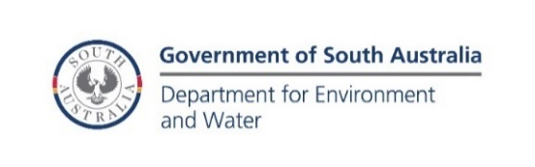
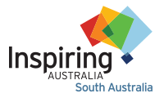

South Australian Citizen Science Award

2024 Nomination Guidelines

Nominations close 10am Tuesday 11 June 2024

Invitation
Inspiring South Australia, the Department for Environment and Water and the South Australian Chapter of the Australian Citizen Science Association (ACSA) are delighted to announce the 2024 awards for outstanding Citizen Science Projects in South Australia. We invite applications from groups and individuals currently engaged in citizen science activities that promote and increase community participation in projects that encompass quality science, engagement and education.

About the Award
Participation in citizen science is growing around the world and is delivering wonderful scientific, educational and social benefits. ACSA defines citizen science as: “citizen science involves public participation and collaboration in scientific research with the aim to increase scientific knowledge”. The profile and capacity of citizen science in South Australia has never been stronger and we want to celebrate these achievements.
This year we are offering two prizes: a first prize of $5,000 and a finalist prize of $2,500. We would encourage the use of these prizes to further support the project or to generate new projects.
Awards will be announced during National Science Week, August 2024.

Eligibility
Active Citizen Science projects currently underway in South Australia are eligible for these awards. “Active” projects include those where data is currently being collected, analysed and/or written-up by volunteers and/or project coordinators and/or researchers. Nominations can be made by the project coordinators, researchers or participants. Please note, while schools are ineligible for this award, they can enter the Oliphant Science Awards.

Criteria
Judges will consider the following criteria. Your project should:
- Actively engage citizens in scientific endeavour
- Build collaboration and partnerships
- Operate legally and ethically
- Demonstrate a genuine scientific outcome
- Benefit both professional and citizen scientists
- Have good data management practices
- Provide feedback to and acknowledgement of contributions of citizen scientists
- Advance community understanding of science

As part of a nomination, you are welcome to include up to three letters of support or testimonials, though these letters are not required.

Key Dates
Nominations open | 22 April 2024
Nominations close | 10am Tuesday 11 June 2024
Nomination assessment | Early July 2024
Finalists notified | By 12 July 2024
Award presentation | 6pm Friday 9 August 2024

Contact
Inquiries are welcome:
Alison Kershaw
Inspiring South Australia Program Manager
8273 9107 (during office hours)

Nominations should be sent via email to:
alison.kershaw@samuseum.sa.gov.au

The Australian Citizen Science Association South Australian Chapter helps to implement the strategic goals, priorities and actions of the Australian Citizen Science Association (ACSA) in this state. We build awareness of ACSA and citizen science in our local communities, and we provide a local voice, representation and communication channel at the national level. Citizen scientists, practitioners and researchers are welcome to join our network. https://citizenscience.org.au/acsa-sa/
Department for the Environment and Water The South Australian Government has created a $2 million Citizen Science fund, to help South Australians who are enthusiastic about nature to contribute to the collective knowledge about our environment. For more information about this work, visit https://www.environment.sa.gov.au/
Inspiring South Australia works collaboratively with the scientists, researchers, arts organisations, community organisations, universities, government agencies and industry to provide all South Australians with opportunities to connect with, learn about and get excited about science, technology, engineering, maths, and medicine (STEMM). https://inspiringsa.org.au/

