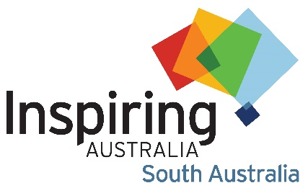
Community Science Engagement and Science Communication Grants 2024

APPLICATION FORM

Name of project
Grant amount requested (up to $3000 for metro Adelaide and up to $4000 for regional and remote)
Organisation name
Organisation type  Tick all that apply | ☐ Community Group  ☐ Government agency  ☐ University  ☐ Sole trader |  | ☐ Business  ☐ Cultural Institution  ☐ Not for profit organisation  ☐ Other
Contact’s name
Contact’s position
Email address
Phone number
Who is/are the target audience(s) for your project? Tick all that apply
☐ First Nations people  ☐ Culturally and Linguistically Diverse people  ☐ Women and girls  ☐ People with disability  ☐ People from low socio-economic backgrounds |  | ☐ Neurodivergent people  ☐ LGBTQIA+ people  ☐ People who face age-based discrimination  ☐ Regional and remote communities  ☐ Other please specify _____________________
Project collaborators (if any) – any other organisations providing in kind, practical (such as presenter, venue or equipment), financial support or are auspicing the grant.
Please provide details of the support being provided
Tell us about your project or event: 500 words maximum
What is/are the aims and objective(s) of the project? 300 words maximum
Tell us about what you want the participants/attendees to explore, learn, connect with or do?
What are the proposed outcomes and outputs of the project? 300 words maximum
Tell us about any recording, handouts or resources that will be available, and/or will the participants create anything they can take home?
How many participants/attendees are you anticipating?
Cost to participants/attendees? What is the charge per person?
Proposed date(s) of the project or activity
Proposed venue(s)/location(s)
Which branch(es) of STEMM eg astronomy, biology or technology does your event feature?
How will you be promoting and marketing this project or event?

Budget
See below for sample budget. Please include the cash amounts you are requesting as well as any in-kind contributions, add extra lines if required
Item | Cash amount requested (ex GST) | In-kind contribution
TOTAL

Sample Budget
Item | Cash amount requested | In-kind contribution
Materials | $350
Marketing and promotion | $150
Speaker fee | $500
Planning staff |  | 25 hrs @ $40/hr = $1000
Venue hire |  | 3hrs @ $50/hr = $150
TOTAL | $1000 | $1150

Please submit your completed application to Alison Kershaw,
Inspiring South Australia Program Manager, alison.kershaw@samuseum.sa.gov.au
by 10am Monday 3 June 2024
Please include the name of the organisation applying for the grant in the file name.

