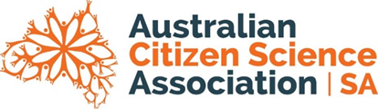
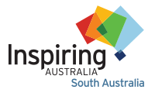
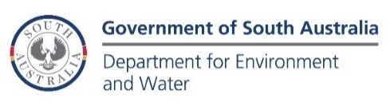

South Australian Citizen Science Award

2024 Nomination

Nominations close 10am Tuesday 11 June 2024

One award of $5000 and one secondary finalist award of $2500 will be awarded to outstanding Citizen Science projects in South Australia.

Before completing this form, please read the South Australian Citizen Science Award 2024 Guidelines.

Your Details
Name
Phone
Email

Name of Citizen Science Project
Briefly describe the project including project objectives, project design and project timeline. (max 250 words)
How has the project actively engaged citizens in scientific endeavour? (max 250 words)
How did the project build collaboration and partnerships? (max 250 words)
How did the project operate legally and ethically (max 250 words)
Tell us about the genuine scientific outcomes of the project (max 250 words)
Tell us about how the project benefited both professional and citizen scientists (max 250 words)
Tell us about the data management practices of the project (max 250 words)
Tell us about how the project provided feedback to and acknowledged the contributions of citizen scientists (max 250 words)
Tell us about how the project has advanced community understanding of science (max 150 words)
Tell us the current status of the project.
Are participants and/or coordinators actively collecting and/or analysing data, or writing papers and/or reports?
If the project is on hiatus due to insufficient resources, when was it last active and what are your plans for the future if resources were to become available? (max 150 words)

As part of a nomination, you are welcome to include up to three letters of support or testimonials, though these letters are not required.

Nominations should be sent via email to:
alison.kershaw@samuseum.sa.gov.au
Inspiring South Australia Program Manager
8273 9107 – during office hours

