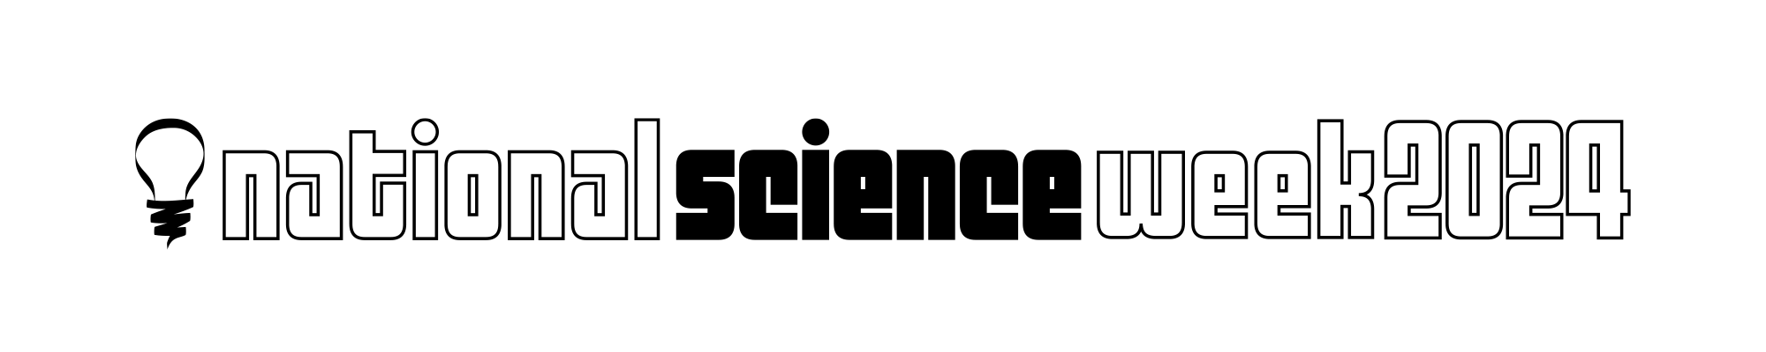

Unsung Hero Awards of South Australian

Science and Science Communication

Nominee Details
Name
Organisation
Email
Phone

Nominator Details:
Name
Email
Phone

Nominating for the Award of:
❑ Unsung Hero of South Australian Science
❑ Unsung Hero of South Australian Science Communication

Evidence for nomination, maximum 1000 words, can be attached as separate document.

Please provide details of the nominee’s length of involvement in their field of STEM or science communication. Detail their achievements such as, but not limited to research, projects, programs, app development and events. Include details of any previous awards or recognition the nominee has received for their work.

Referees
Please provide up to two people who the Assessment Panel may contact to get more information about the work and impact of the nominee.

Referee 1
Name
Organisation
Email
Phone

Referee 2
Name
Organisation
Email
Phone

If you have any questions, please contact:
Alison Kershaw
Inspiring SA Program Manager
inspiringsa@sa.gov.au
8273 9107 – during office hours

Submit your completed nomination to inspiringsa@sa.gov.au

Nominations will close at 10am

Tuesday 11 June 2024.

